Assignment 1

Number 1

RIGBoat proposal

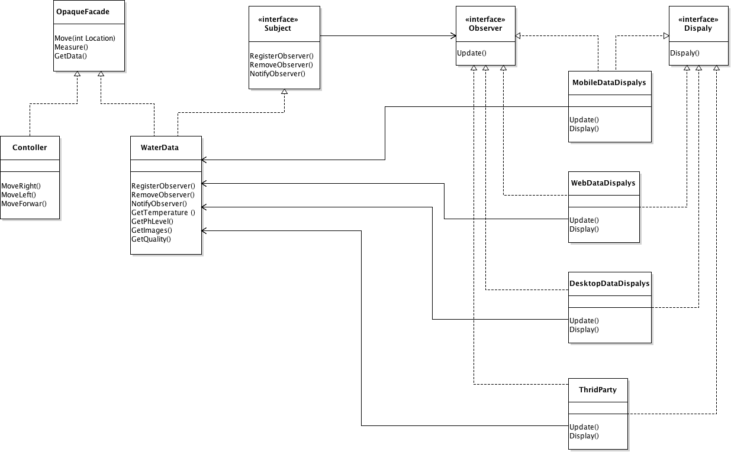

We can use **OpaqueFaçade** design pattern to divide our classes into two subclasses, the first is the **Controller** that will control the RIGboat where only authorized users can access it, while the **WaterData** is a subclass that is responsible for acquiring data from the water and save it. Moreover, it will enhance user’s experience by allowing the ability to control and acquire data at the same time with less effort.

Observer design pattern should be used too to make sure all mobile devices or any other type of devices connected to the system will receive data updates whenever **WaterData** class is updated.

**WaterData** is the Concrete Subject class in Observer pattern and ConcreteObservers are the **MobileDataDipsay** , **WebDataDisplay**, **DesktopDataDisplay** , and **ThirdParty** that will use our API to use the data they receive .

Two Interfaces are used to implement abstract classes that each of the ConcreteObservers will use to implement overridden methods.